

Installation manual v1.0

Inhoud
Installing via Docker Desktop 3
Troubleshooting 6
FAQ 7

Installing via Docker Desktop
The easiest way to install and run matchY is via Docker.
- Go to https://www.docker.com/products/docker-desktop/ and download the latest version of Docker Desktop for your platform (Windows, Mac or Linux).
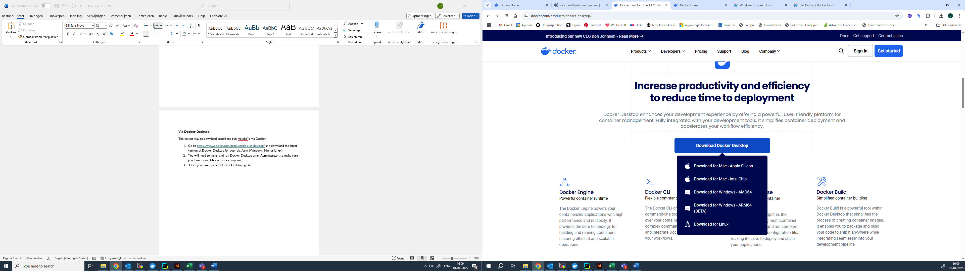

- You will need to install and run Docker Desktop as an Administrator, so make sure you have those rights on your computer.
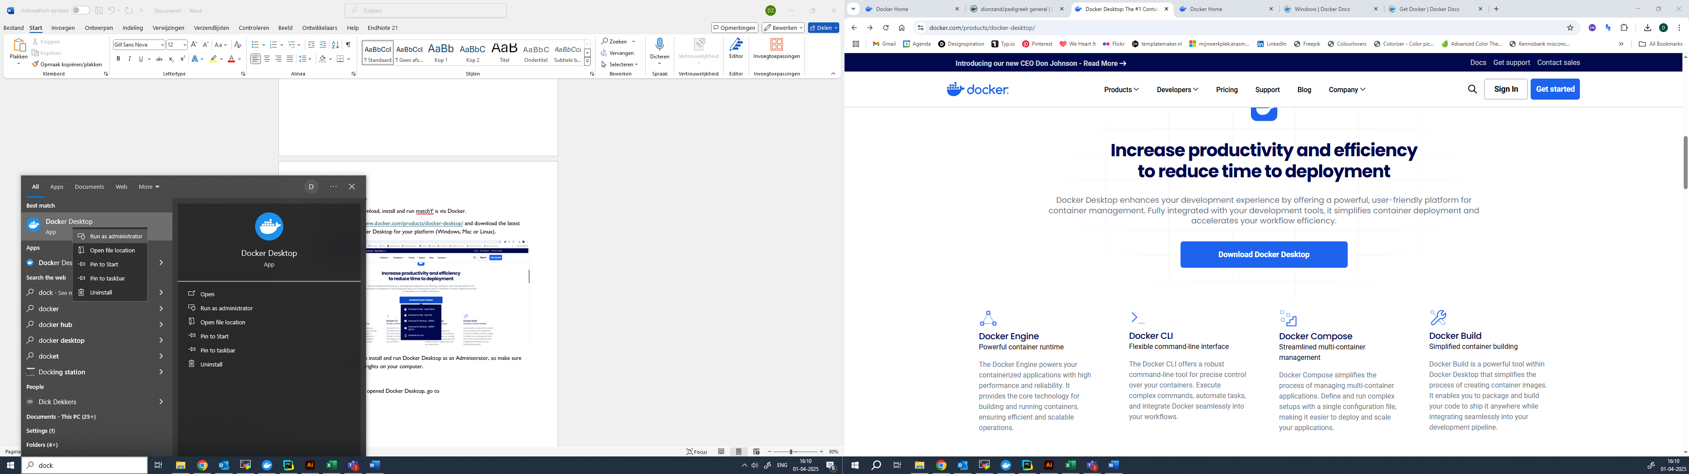

- Open Docker Desktop (see Troubleshooting if you encounter an error).
- Once you have opened Docker Desktop, go to Docker Hub in the left menu bar and search for “dionzand/pedigreelr”
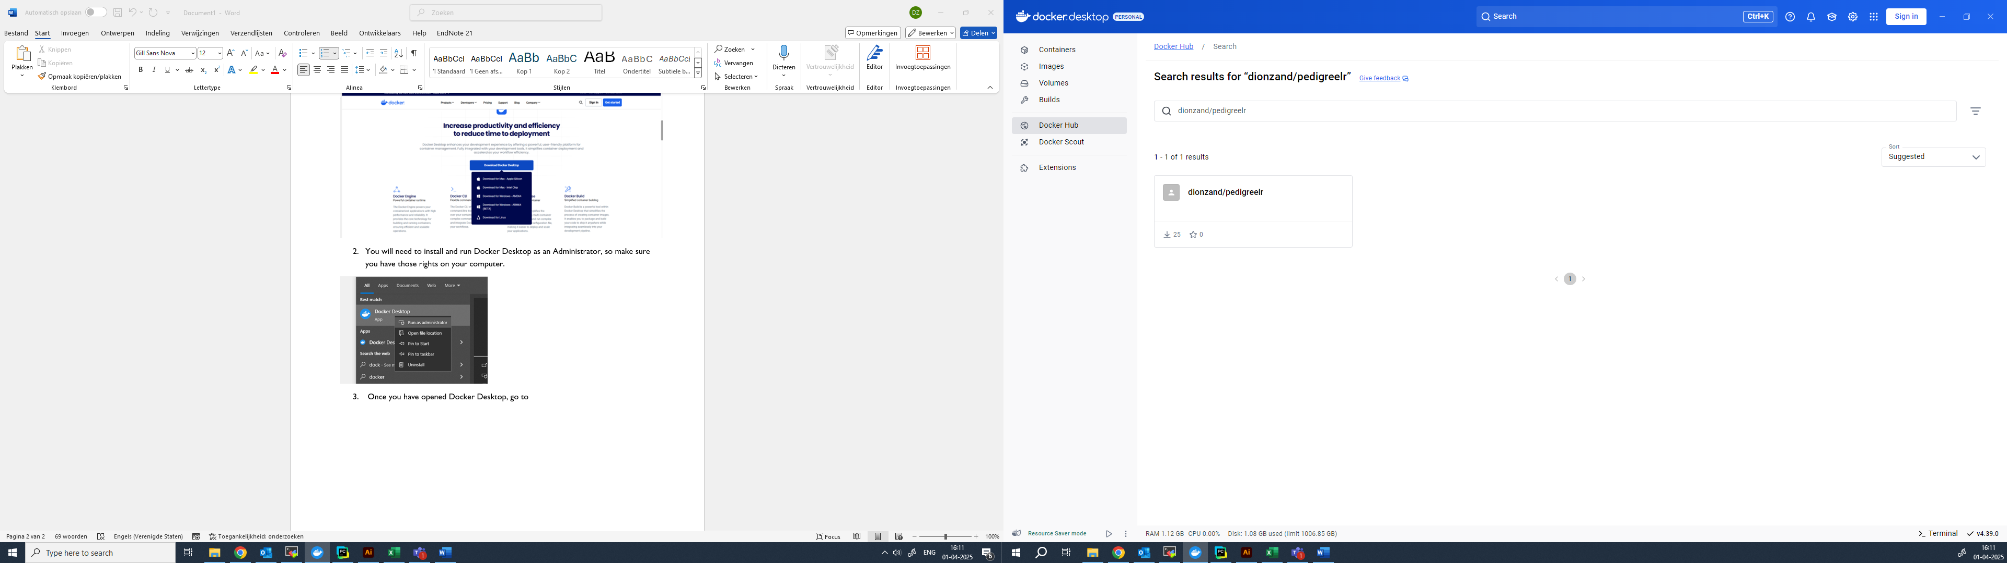

- Open the search result and in the top right corner click “Run”
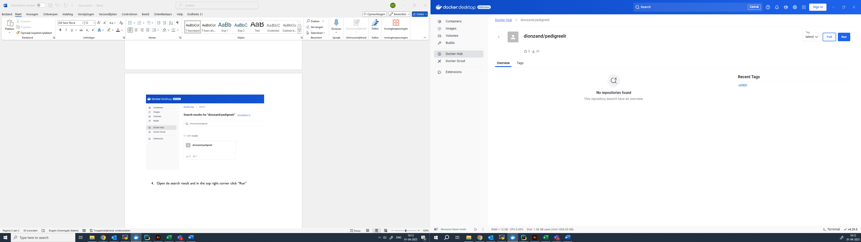

- The software is now being downloaded to your computer. Once the download is completed, you are prompted with the following window:
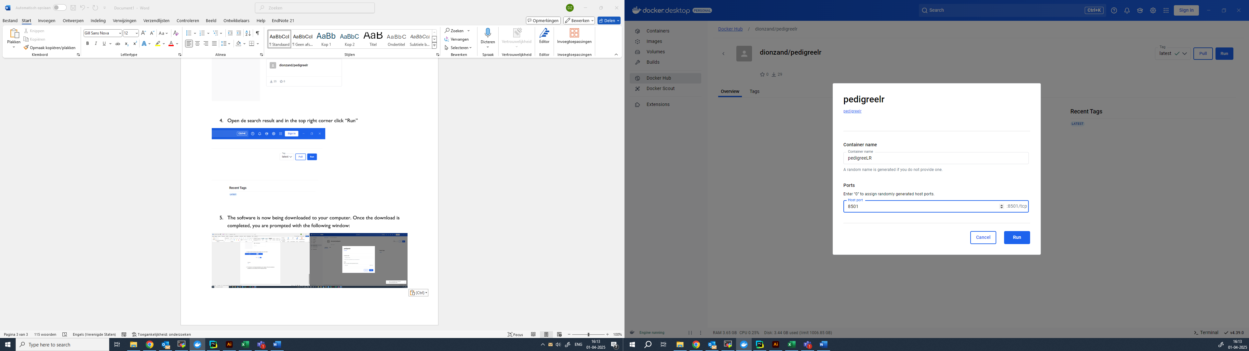
- As a Container name, give it a name you like, for instance “matchY”.
- For Host port, fill in a free port on your local network, preferably port “8501”.
- Click Run. MatchY is now starting up and you should see the logs produced by the software.
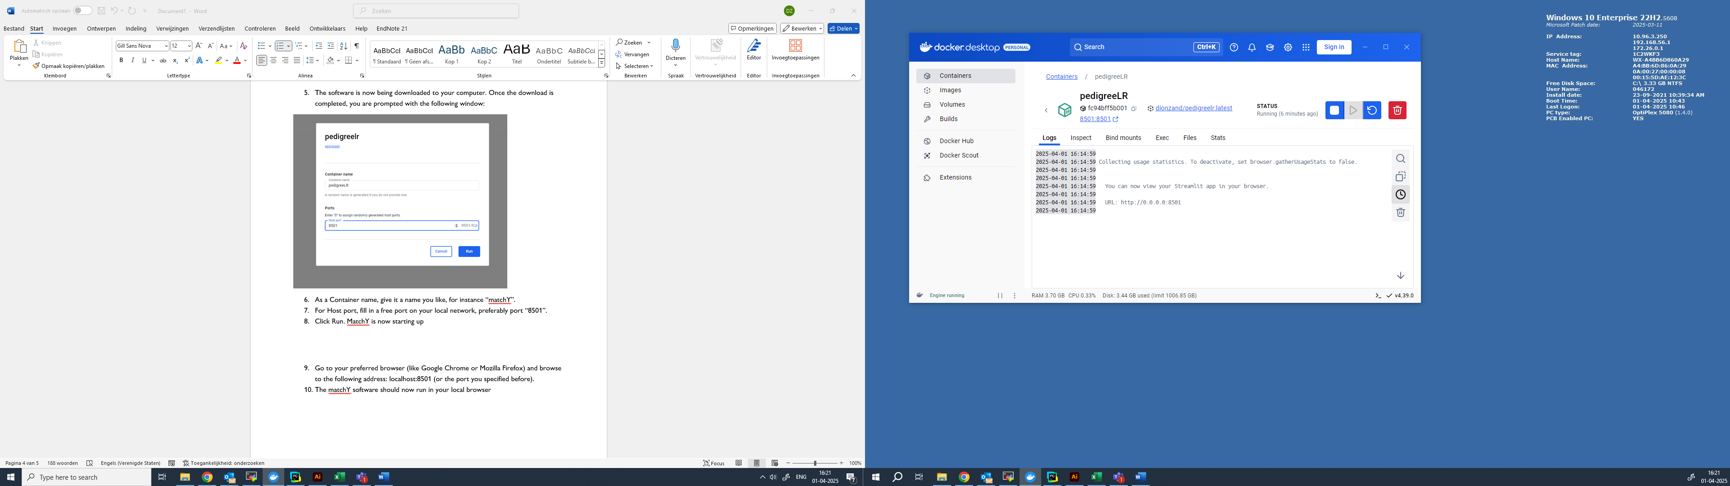

- Go to your preferred browser (like Google Chrome or Mozilla Firefox) and browse to the following address: localhost:8501 (or the port you specified before).
- The matchY software should now be available to all users on your local network.
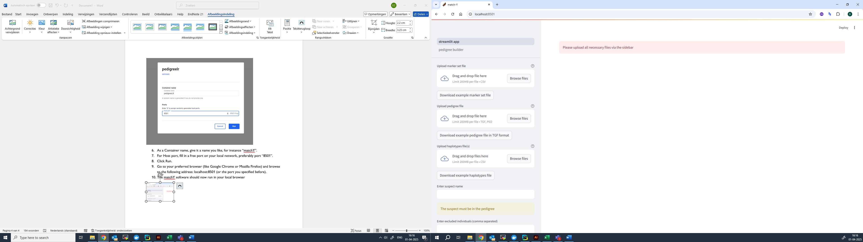

Troubleshooting
Problems with WSL
Docker Desktop on Windows depends on WSL (Windows Subsystem for Linux). When opening Docker Desktop for the first time, you might get an error that is related to WSL. To fix this, make sure WSL is correctly installed on your Windows computer:
- Open Windows PowerShell as Administrator
- Enter the following commands:
  - wsl --install
  - wsl --install -d Ubuntu
  - wsl --set-default-version 2
  - wsl --set-default Ubuntu
  - wsl --set-version Ubuntu 2
This should make sure that the correct version of WSL is installed and activated. When you now restart Docker Desktop, it should work.
Sometimes, however, you will get the error message “WSL2 is not supported with your current machine configuration”. This is a bit more difficult to solve, since this sometimes requires you to change some settings in your BIOS.
- Open Windows PowerShell as Administrator
- Enter the following command:
  - Enable-WindowsOptionalFeature -Online -FeatureName VirtualMachinePlatform, Microsoft-Windows-Subsystem-Linux
  - DISM /Online /Enable-Feature /All /FeatureName:Microsoft-Hyper-V
  - bcdedit /set hypervisorlaunchtype auto
- Reboot your computer and restart Docker Desktop
If this did not solve the problem, you will need to enable Virtualization in your BIOS. How to do this exactly depends on the system you are using. Please try to fix it via this link: https://www.ninjaone.com/blog/how-to-enable-cpu-virtualization-in-your-computer-bios/

FAQ
- How can I update matchY once a new version is available?
Stop and remove the Container where your current instance of matchY is running. Remove the old Image of matchY. Follow the installation manual again from step 4.
- How do I start matchY the next time when I want to use it?
If you did not fully shut down Docker Desktop, matchY might still be running in the background and you can still using it by browsing to localhost:8501. If Docker Desktop is not running anymore, open it again (in Administrator mode), go to Containers, and click Run to restart your previous session.
- Can I run multiple instances of matchY?
Yes. While it is not necessary, you can start multiple Containers from the same Image in Docker Desktop. Go to Images and click Run. Make sure that you give each new instance a different host port (i.e. 8502, 8503, etc.). However, you can use the same Container simultaneously on multiple computers and or tabs in your browser, so starting a new instance might only be useful if you want to keep your computational resources divided between instances.
- Why can’t I open matchY via localhost:8501 in my browser?
Make sure that you have an Container with matchY running in Docker Desktop. Make sure that the host port in this Container is set to the correct host port. Also check if you are using http and not https in front of your localhost:8501 URL.
- Why is Docker Desktop not opening?
Make sure you are opening Docker Desktop as an Administrator.
- What is Docker Desktop?
Docker Desktop is a virtualization and containerization software. It is used to share and run containerized applications. matchY is build in a Python environment. To be able to run matchY with as little programming knowledge as possible, we distribute matchY as a Docker Image.

